# Question 1

墙上的钟表

# Question 2

$Expected Time = \frac{1}{6}[Optimistic Time (a)+ 4×Most Likely Time (m)+ Pessimistic Time (b)]$

$Std. Deviation = \frac{1}{6}[Pessimistic Time (b) - Optimistic Time (a)]$

$Total Std. Dev. = \sqrt{s{d_{1}}^{2}+s{d_{2}}^{2}+...+s{d_{n}}^{2}}=\sqrt{\sum_{i=1}^{n}{}s{d_{i}}^{2}}$

| **TASK** | Most Likely Time | Optimistic Time | Pessimistic Time | Expected Time | Standard Deviation |
| --- | --- | --- | --- | --- | --- |
| **m** | **a** | **b** | **Exp Dur** | **Std Dev** |
| A | 4 | 3 | 5 | 4 | 0.333333 |
| B | 8 | 8 | 14 | 9 | 1 |
| C | 6 | 4 | 8 | 6 | 0.666667 |
| D | 7 | 4 | 10 | 7 | 1 |
| E | 10 | 9 | 17 | 11 | 1.333333 |
| F | 9 | 8 | 10 | 9 | 0.333333 |
| G | 9 | 7 | 11 | 9 | 0.666667 |
| H | 4 | 2 | 6 | 4 | 0.666667 |
| I | 12 | 12 | 18 | 13 | 1 |
| J | 12 | 11 | 13 | 12 | 0.333333 |
| K | 2 | 2 | 2 | 2 | 0 |
| L | 3 | 2 | 4 | 3 | 0.333333 |
| **Total Standard Deviation** | | | | | 2.560382 |

# Question 3

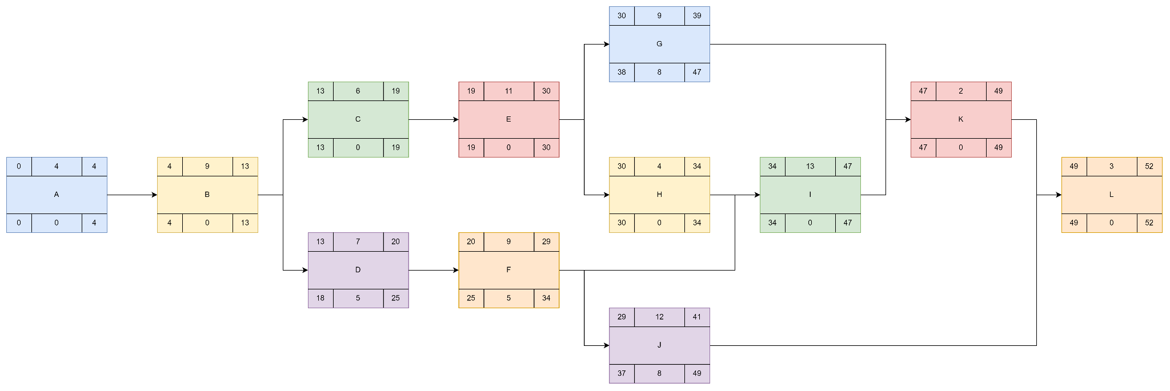

| **TASKS** | Earliest Start | Duration | Earliest Finish | Latest Start | Float | Latest Finish |
| --- | --- | --- | --- | --- | --- | --- |
| **ES** | **DUR** | **EF** | **LS** | **FLT** | **LF** |
| **A** | 0 | 4 | 4 | 0 | 0 | 4 |
| **B** | 4 | 9 | 13 | 4 | 0 | 13 |
| **C** | 13 | 6 | 19 | 13 | 0 | 19 |
| **D** | 13 | 7 | 20 | 18 | 5 | 25 |
| **E** | 19 | 11 | 30 | 19 | 0 | 30 |
| **F** | 20 | 9 | 29 | 25 | 5 | 34 |
| **G** | 30 | 9 | 39 | 38 | 8 | 47 |
| **H** | 30 | 4 | 34 | 30 | 0 | 34 |
| **I** | 34 | 13 | 47 | 34 | 0 | 47 |
| **J** | 29 | 12 | 41 | 37 | 8 | 49 |
| **K** | 47 | 2 | 49 | 47 | 0 | 49 |
| **L** | 49 | 3 | 52 | 49 | 0 | 52 |

# Question 4

$z=\frac{(Target Completion Time - Expected Completion Time)}{Std. Dev.}=\frac{(T-t_{e})}{s}=\frac{(55-52)}{2.560382}=1.1717$

According to the Z-Score table, the rough probability of z-value 1.17 is 0.8790, which yields a probability of 87.9% of finishing the project on time.

# Question 5

Number of specialists of each type needed on each day of the project.



# Question 6

Number of specialist of each type needed on each day of the project (constrainted).



# Question 7

The delay caused by the constraint is 5 days.